Linux commands

CSE 250 Assignement 3

Karan (E0119039)

2020

1.pwd command

Use the **pwd** command to find out the path of the current working directory (folder) you’re in. The command will return an absolute (full) path, which is basically a path of all the directories that starts with a forward slash **(/)**. An example of an absolute path is **/home/username**.

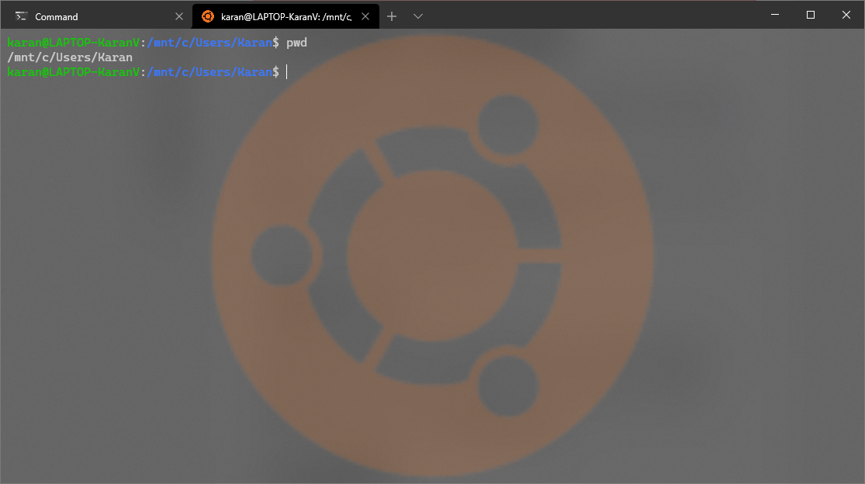

2. cd command

To navigate through the Linux files and directories, use the **cd** command. It requires either the full path or the name of the directory, depending on the current working directory that you’re in.

Let’s say you’re in **/home/username/Documents** and you want to go to **Photos**, a subdirectory of **Documents**. To do so, simply type the following command: **cd** **Photos**.

Another scenario is if you want to switch to a completely new directory, for example, **/home/username/Movies**. In this case, you have to type **cd** followed by the directory’s absolute path: **cd /home/username/Movies**.

There are some shortcuts to help you navigate quickly:

* **cd ...** (with two dots) to move one directory up
* **cd**to go straight to the home folder
* **cd-** (with a hyphen) to move to your previous directory

On a side note, Linux’s shell is case sensitive. So, you have to type the name’s directory exactly as it is.



**3. ls command**

The**ls** command is used to view the contents of a directory. By default, this command will display the contents of your current working directory.

If you want to see the content of other directories, type **ls** and then the directory’s path. For example, enter **ls** **/home/username/Documents** to view the content of **Documents**.

There are variations you can use with the **ls** command:

* **ls -R** will list all the files in the sub-directories as well
* **ls -a** will show the hidden files
* **ls -al** will list the files and directories with detailed information like the permissions, size, owner, etc.

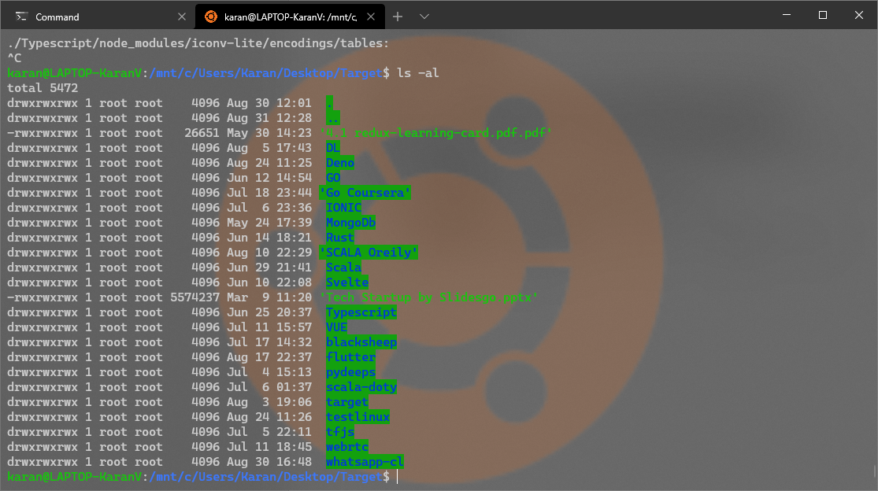

**4.cat command**

**cat** (short for concatenate) is one of the most frequently used commands in Linux. It is used to list the contents of a file on the standard output (sdout). To run this command, type **cat** followed by the file’s name and its extension. For instance: **cat file.txt**.

Here are other ways to use the **cat** command:

* **cat > filename**creates a new file
* **cat filename1 filename2>filename3**joins two files (1 and 2) and stores the output of them in a new file (3)
* to convert a file to upper or lower case use, **cat filename | tr a-z A-Z >output.txt**



**5.  cp command**

Use the cp command to copy files from the current directory to a different directory. For instance, the command cp scenery.jpg /home/username/Pictures would create a copy of scenery.jpg (from your current directory) into the Pictures directory.



**6. mv command**

The primary use of the **mv** command is to move files, although it can also be used to rename files.

The arguments in mv are similar to the cp command. You need to type **mv**, the file’s name, and the destination’s directory. For example: **mv file.txt /home/username/Documents**.

To rename files, the Linux command is **mv oldname.ext newname.ext**

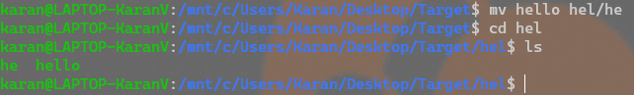

**7. mkdir command**

Use **mkdir** command to make a new directory — if you type **mkdir Music** it will create a directory called **Music**.

There are extra **mkdir** commands as well:

* To generate a new directory inside another directory, use this Linux basic command **mkdir Music/Newfile**
* use the **p**(parents) option to create a directory in between two existing directories. For example, **mkdir -p Music/2020/Newfile** will create the new “2020” file.

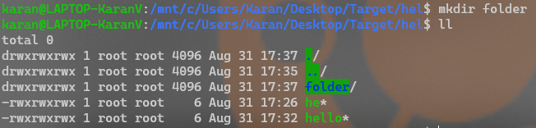

**8. rmdir command**

If you need to delete a directory, use the **rmdir** command. However, rmdir only allows you to delete empty directories.

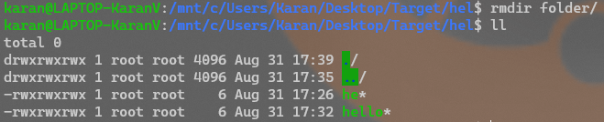

**9. rm command**

The **rm** command is used to delete directories and the contents within them. If you only want to delete the directory — as an alternative to rmdir — use **rm -r**.

**Note**: Be very careful with this command and double-check which directory you are in. This will delete everything and there is no undo

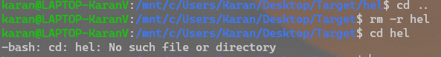

**10. touch command**

The **touch** command allows you to create a blank new file through the Linux command line. As an example, enter touch **/home/username/Documents/Web.html** to create an HTML file entitled **Web** under the **Documents** directory.



**11. Find command**

You can use this command to **locate** a file, just like the search command in Windows. What’s more, using the **-i** argument along with this command will make it case-insensitive, so you can search for a file even if you don’t remember its exact name.

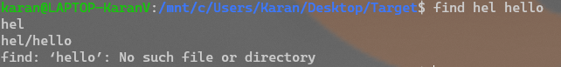

**12. grep command**

Another basic Linux command that is undoubtedly helpful for everyday use is **grep**. It lets you search through all the text in a given file.

To illustrate, **grep blue notepad.txt** will search for the word blue in the notepad file. Lines that contain the searched word will be displayed fully.



**13. sudo command**

Short for “**SuperUser Do**”, this command enables you to perform tasks that require administrative or root permissions. However, it is not advisable to use this command for daily use because it might be easy for an error to occur if you did something wrong.



**14. df command**

Use **df** command to get a report on the system’s disk space usage, shown in percentage and KBs. If you want to see the report in megabytes, type **df -m**.

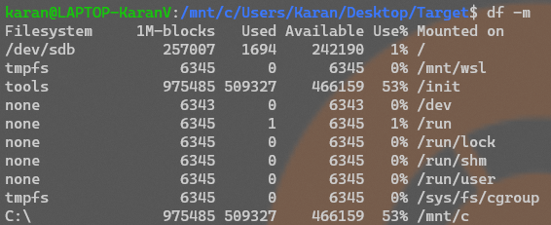

**15. du command**

If you want to check how much space a file or a directory takes, the **du** (Disk Usage) command is the answer. However, the disk usage summary will show disk block numbers instead of the usual size format. If you want to see it in bytes, kilobytes, and megabytes, add the **-h** argument to the command line.



**16. head command**

The**head** command is used to view the first lines of any text file. By default, it will show the first ten lines, but you can change this number to your liking. For example, if you only want to show the first five lines, type **head -n 5 filename.ext**.



**17. tail command**

This one has a similar function to the head command, but instead of showing the first lines, the **tail** command will display the last ten lines of a text file. For example, **tail -n filename.ext.**



**18. diff command**

Short for difference, the **diff** command compares the contents of two files line by line. After analyzing the files, it will output the lines that do not match. Programmers often use this command when they need to make program alterations instead of rewriting the entire source code.

The simplest form of this command is **diff file1.ext file2.ext**

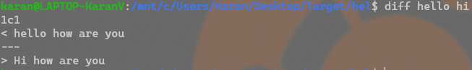

**19. chmod command**

**chmod** is another Linux command, used to change the read, write, and execute permissions of files and directories.

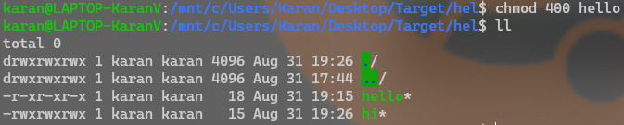

**20. chown command**

In Linux, all files are owned by a specific user. The **chown** command enables you to change or transfer the ownership of a file to the specified username. For instance, **chown linuxuser2 file.ext** will make **linuxuser2** as the owner of the **file.ext**.

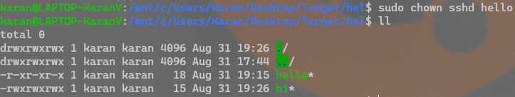

**21.htop command**

htop is an interactive system-monitor process-viewer and process-manager. It is designed as an alternative to the Unix program top. It shows a frequently updated list of the processes running on a computer, normally ordered by the amount of CPU usage. Unlike top, htop provides a full list of processes running, instead of the top resource-consuming processes. htop uses color and gives visual information about processor, swap and memory status. htop can also display the processes as a tree.

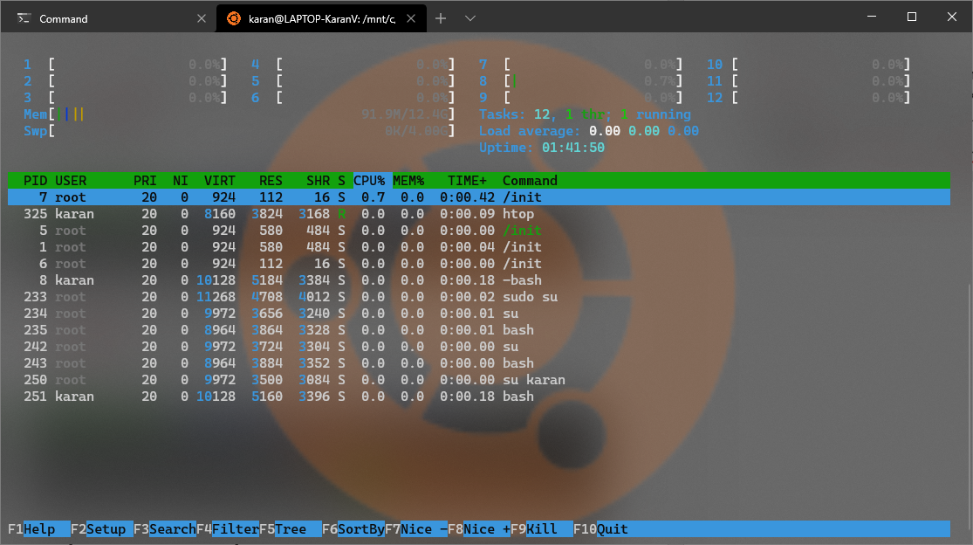

**22. ping command**

Use the **ping** command to check your connectivity status to a server. For example, by simply entering **ping google.com**, the command will check whether you’re able to connect to Google and also measure the response time.

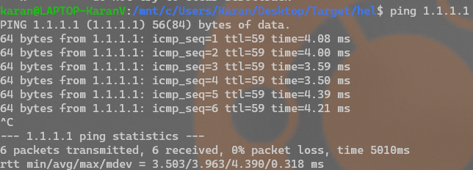

**23. wget command**

The Linux command line is super useful — you can even download files from the internet with the help of the **wget** command. To do so, simply type **wget** followed by the download link.

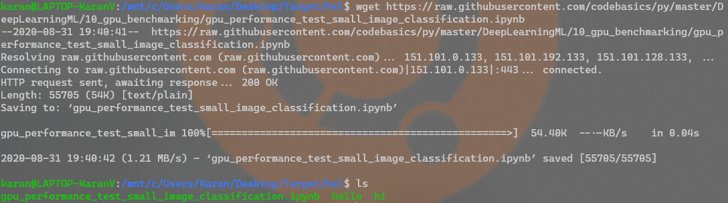

**24. uname command**

The **uname** command, short for Unix Name, will print detailed information about your Linux system like the machine name, operating system, kernel, and so on.



**25. history command**

When you’ve been using Linux for a certain period of time, you’ll quickly notice that you can run hundreds of commands every day. As such, running **history** command is particularly useful if you want to review the commands you’ve entered before.

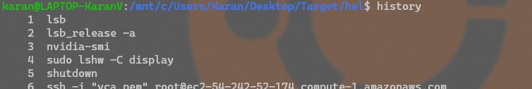

**26. man command**

Confused about the function of certain Linux commands? Don’t worry, you can easily learn how to use them right from Linux’s shell by using the **man** command. For instance, entering **man tail** will show the manual instruction of the tail command.

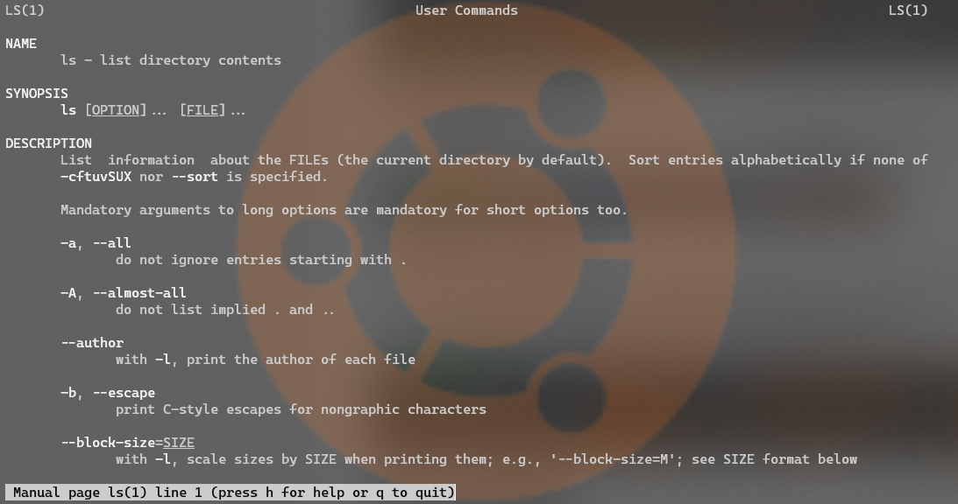

**27. echo command**

This command is used to move some data into a file. For example, if you want to add the text, “Hello, my name is John” into a file called name.txt, you would type **echo Hello, my name is Karan** **>> name.txt**



**28. zip, unzip command**

Use the **zip** command to compress your files into a zip archive, and use the **unzip** command to extract the zipped files from a zip archive.

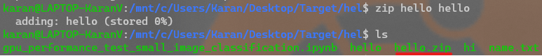

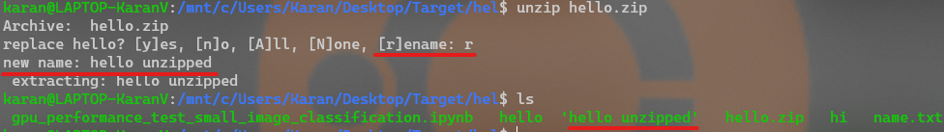

**29. hostname command**

If you want to know the name of your host/network simply type **hostname**. Adding a **-I** to the end will display the IP address of your network.



**30.rm command**

rm stands for **remove** here. rm command is used to remove objects such as files, directories, symbolic links and so on from the file system like UNIX. To be more precise, rm removes references to objects from the filesystem, where those objects might have had multiple references (for example, a file with two different names). **By default, it does not remove directories.**

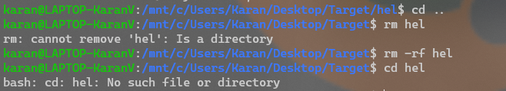

**31. ifconfig command**

**ifconfig**(interface configuration) command is used to configure the kernel-resident network interfaces. It is used at the boot time to set up the interfaces as necessary. After that, it is usually used when needed during debugging or when you need system tuning. Also, this command is used to assign the IP address and netmask to an interface or to enable or disable a given interface.

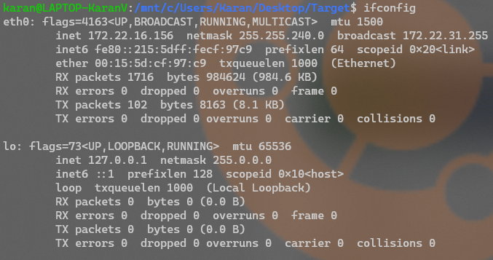

**32.ip command**

**ip**command in Linux is present in the net-tools which is used for performing several network administrations tasks. IP stands for Internet Protocol. This command is used to show or manipulate routing, devices, and tunnels. It is similar to [*ifconfig*](https://www.geeksforgeeks.org/ifconfig-command-in-linux-with-examples/) command but it is much more powerful with more functions and facilities attached to it. *ifconfig* is one of the deprecated commands in the net-tools of Linux that has not been maintained for many years. ip command is used to perform several tasks like assigning an address to a network interface or configuring network interface parameters.  
It can perform several other tasks like configuring and modifying the default and static routing, setting up tunnel over IP, listing IP addresses and property information, modifying the status of the interface, assigning, deleting and setting up IP addresses and routes.

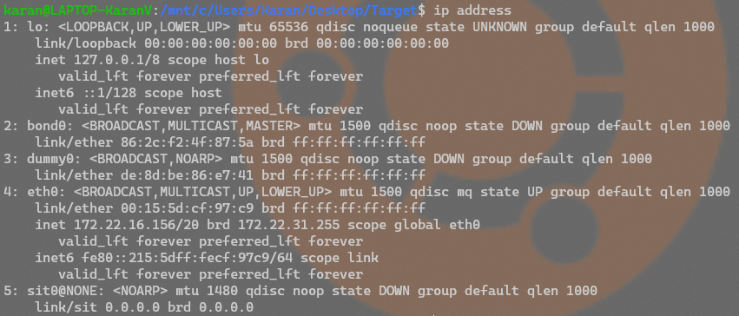

**33.nslookup command**

**Nslookup**(stands for “Name Server Lookup”) is a useful command for getting information from DNS server. It is a network administration tool for querying the Domain Name System (DNS) to obtain domain name or IP address mapping or any other specific DNS record. It is also used to troubleshoot DNS related problems.

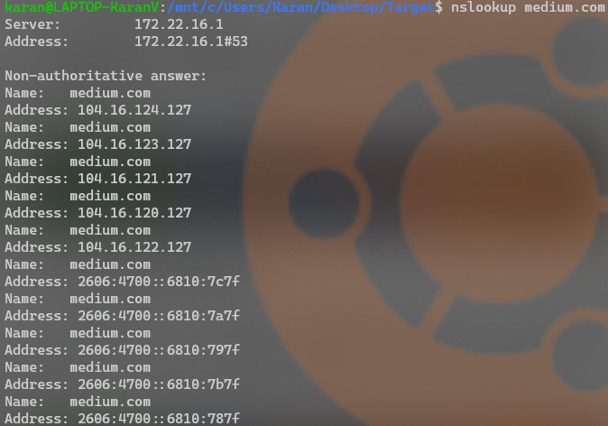

**34.rev command**

The rev command will print the reverse of whatever you type in. First run rev, then start typing one sentence at a time



**35.telnet command**

In Linux, the **telnet** command is used to create a remote connection with a system over a TCP/IP network. It allows us to administrate other systems by the terminal. We can run a program to conduct administration.

It uses a TELNET protocol. However, this protocol has some security defects, but it is one of the most used networking protocols due to its simplicity. It is not a secure protocol because it transfers data in unencrypted form. Often Linux user prefers **ssh** over telnet because ssh transfers data in encrypted form. This utility is similar to the Remote Desktop feature in Windows.

